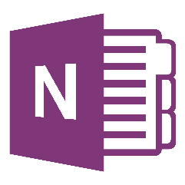
OneNote Class
Notebooks for Beginners
Organize and share your files electronically using Office 365 OneNote. Learn how you can create OneNote notebooks for cloud based organizations and file sharing. Dig deeper to deliver curriculum and collaborate with students and colleagues. This is a tool you've got to see!
Team Strand: Activities and Materials
ISTE Teacher Standard: Develop and model cultural understanding and global awareness by engaging with colleagues and students of other cultures using digital age communication and collaboration tools.
Bellwork: Watch this video https://www.youtube.com/watch?v=dJKX-GVI5Z0
Session Objectives:
- Review examples of OneNote Notebooks

- Create a notebook for personal use

  - Share
  - Options/Ribbon

- Explore Class NoteBook from a student perspective
  - Collaboration Space
  - Content Library
  - Individual Student Notebook Section

- Create a notebook for PLC or student use
  - Options/Ribbon
  - Advanced Features (if time allows)

- Review of OneNote Notebooks vs. OneNote Class Notebooks

- Need help? Want to move forward?
  - http://www.onenoteineducation.com/
  - http://onenoteforteachers.com/en-US/Guides/Collaborating%20in%20the%20classroom%20with%20the%20OneNote%20Class%20Notebook%20Creator

- Evaluation

