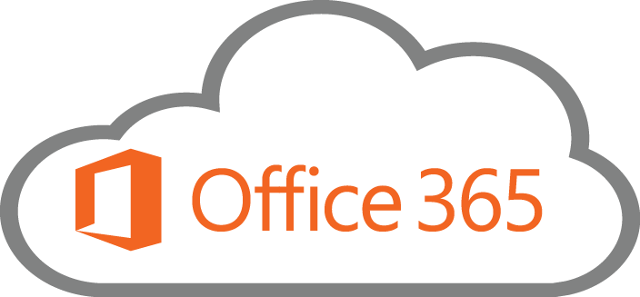
Office 365: Everything 365—Advanced

Bell Work- Locate and join our group in Office 365: BHS Technology Inservices.

Access Tiles- Overview of 365 Options (2 Minutes)
- Mail, People, Calendar (Groups are included under each)
- One Drive
- Word, Power Point, Excel, One Note
- Delve
- Video
- Sway
- Tasks
- Sites

Compare the different ways of sharing and viewing files.
- OneDrive
- Groups
- OneNote

Join a Group and explore the options
- Sharing Files
- Calendar Invitation to Online Meeting
- Setup Online Meeting Invite
- Skype

Add a calendar event for an Online Meeting to Personal and Group Calendar- Skype
- Record Skype Meeting
- Using Skype to record instruction

Video Portal
- Post Skype recording to the Video Portal _____ Channel
- Video Portal Settings
- Sharing in the video portal

Locate Files using Delve
- Locate Files Searching

One Drive
- Create New Folder
- Create a New File
- Share- Folder or File
- Edit Shared File- Notice Version History
- Excel Survey

One Note- Class Notebooks and Staff Notebooks
- This is a separate in-service. http://www.onenoteforteachers.com/
- Example of a One Note Class or Staff Notebook. How could you use this with your students? PLC? Department? Others?

Outlook
- Email
- Calendar
- People
Microsoft Educator Community: https://education.microsoft.com/
Road Map: http://roadmap.office.com/en-us
Evaluation: http://bit.ly/1OQY88v

