Nearpod: The interactive presentation program for BYOD
While you’re waiting … Watch this video! https://www.youtube.com/watch?v=oOhwDAC-aok
With Nearpod, teachers can create and download interactive multimedia presentations, share content and assessments in real time, monitor classroom activity, and easily control students' devices.
How do the students access Nearpod?
- Download the Nearpod app on their devices (available in the iTunes store, Google Play store, and the Windows store)
- Go to www.nearpod.com and click Join Session
Experience Nearpod as a student …
Go to www.nearpod.com and click Join Session (don’t log in or create an account just yet!)
Enter the PIN number on the projector screen. When you do this with a class, you will not project your screen for the students to see. Today, however, I want you to see both the teacher and student views.
Create your own Nearpod presentation …
After creating your Nearpod account using your email address or your Google account, choose Create from your home screen.
- Nearpod provides you with your opening and closing slides. Choose Add Slide.
  - Add Content – informational slide
    - Slide
    - Video
    - Audio (free trial)
    - Slide show
    - Field trip (free trial)
    - PDF viewer (free trial)
    - Twitter stream (free trial)
  - Add Web Content – share a webpage that students can navigate on their own (free trial)
  - Add Activity – interactive content (polls, quizzes, drawings, etc.)
    - Open-ended question
    - Poll
    - Quiz
    - Draw It
    - Fill-in-the-blank (free trial)
    - Memory test (free trial)
- Even better … you can upload your pre-existing PowerPoint presentations into Nearpod and just add the interactive content!!!!
- When you are finished creating your presentation, don’t forget to move your closing slide to the end of your presentation!

While presenting to a class …
- Do not project your screen to ensure that all student answers are confidential.
- You control the speed of the presentation. Allow plenty of time for the students to read the information on the screen, view pictures or video, navigate webpages, etc.
- When you see a wonderful answer from a student, you can share it with the class!! No names are displayed. This is a great way to generate class discussion about the answers.
- You can skip slides or navigate out of order by using the slide viewer at the bottom of your screen.
When you are finished presenting …
- You can access all of your students’ answers on each interactive activity and generate reports.
- From the home screen, choose reports. Then find the presentation and session date that you wish to generate a report for.
- You will be able to download a PDF report for each session.
Explore option …
There are many free NPPs (Nearpod presentations) that you can search through and duplicate to your library to use with your class.
There are also presentations created by Time for Kids, LearnZillion, TedEd, Khan Academy, etc. for your use.
It’s a great resource!
With the paid version …
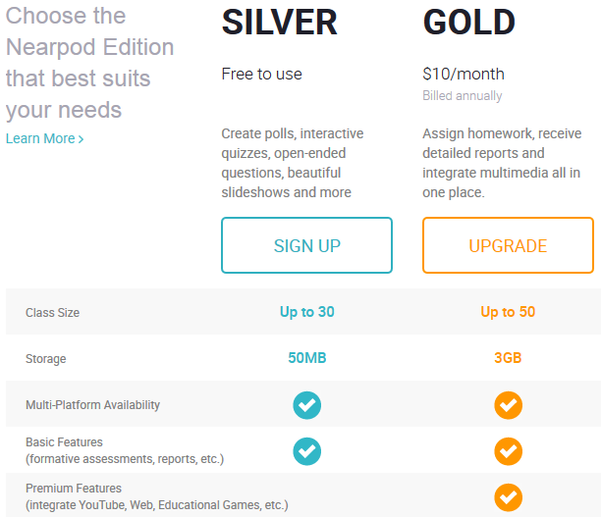

Please complete the inservice evaluation here: http://bit.ly/1OQY88v
Nearpod: The interactive presentation program for BYOD

11/23/15 3:45-5:45 Blackman High School Room G21
Trying to figure out how to integrate BYOD into your everyday lessons? Looking for a way to make your PowerPoint presentations engaging? Come learn about Nearpod! You can import your pre-existing PowerPoint presentations and embed formative questions, polls, videos, and quizzes. Students access your presentation on their devices and you get great data reports after each presentation. Free and easy to use ... leave this session with a lesson ready to go!
TEAM Strand: Motivating Students

Notes:

